PRECINCT NEWSLETTER
GENERAL ELECTION EDITION
November 2022

Name, Precinct #___ Republican Chair
Address, Houston, TX Zip

Dear Neighbor,
STRAIGHT-TICKET VOTING IS GONE IN TEXAS; VOTE FOR THE DOWN-BALLOT RACES!
Harris County is less safe than it was four years ago:
- Every judge except one in Harris County is a Democrat
- Over 180 victims murdered by criminals out on bond
- 436% increase of violent offenders receiving a PR (free) bond
- 135,000 unresolved criminal cases

County Judge Lina Hidalgo has damaged the criminal justice system in Harris County by starving law enforcement of resources and supporting the release of repeat, violent offenders out on bond, creating unsafe neighborhoods. That’s why I’m asking you to vote for Alexandra del Moral Mealer for County Judge.
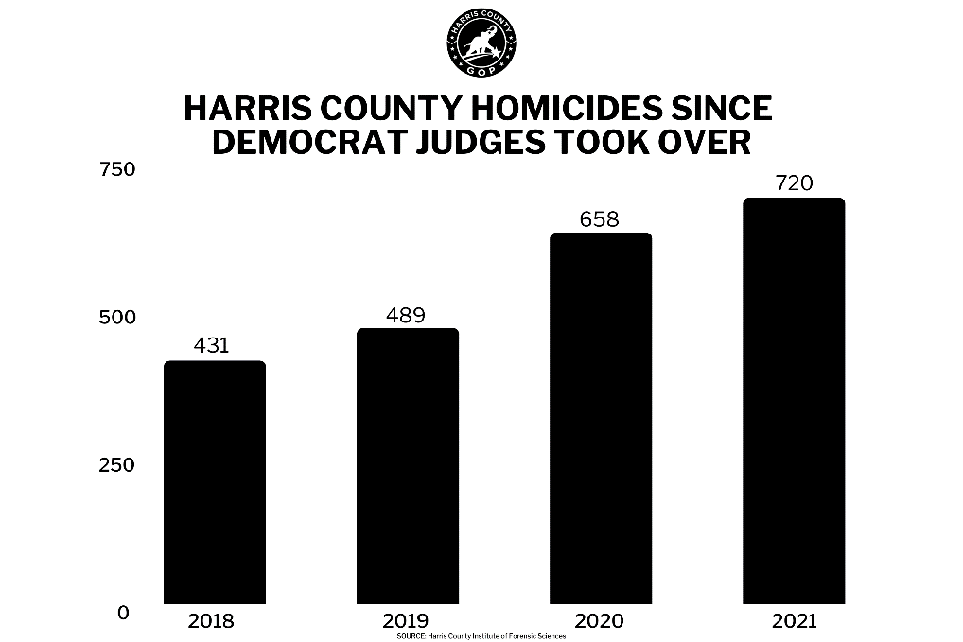

With Alexandra del Moral Mealer for County Judge and all the Republican Judicial Candidates, we can restore a safer Harris County and keep violent criminals off our streets. Be sure to vote for all the local Republican candidates on your ballot this cycle.

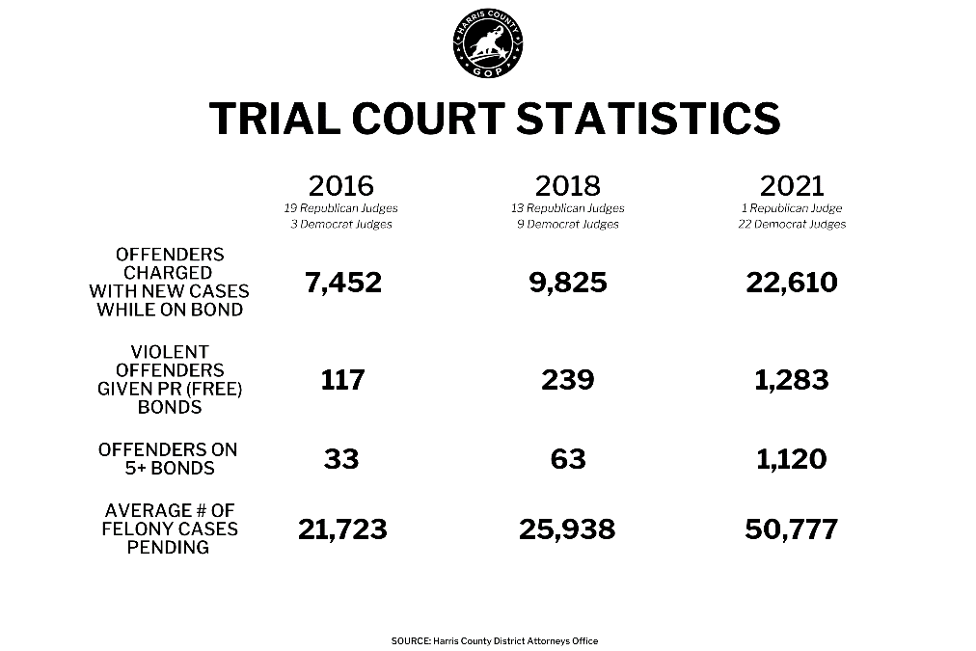

IMPORTANT INFORMATION:
Friday, November 4: Last Day of Early Voting
Tuesday, November 8: Election Day

- Find your Nearest Polling Location: https://www.harrisvotes.com/Polling-Locations

- Find your Voter Registration Info: http://www.harrisvotes.com/

Find your Complete Ballot at: https://www.harrisvotes.com/Voter/Whats-on-my-Ballot

DOWN-BALLOT VOTING IS IMPORTANT
- Government has a greater impact locally than nationally.

- Local government is the crucible of the state and federal government leadership of tomorrow.

- Local government affects our crime rates and safety.

Sincerely,

Name
Your Precinct Chair #____

